1. Justification for selecting a specific architecture pattern for Case study project

Case study Cojis project is a 3-tier web-based architecture pattern which is composed of 3 tires of logical computing, Presentation Tier: modularizing the user interface, Application Tier: business logic, and Data Tier: data storage layers

1. Logical and Physical diagrams of the chosen architecture pattern for Case study project

Logical Diagram:

Logical diagram is a generic abstraction of the architecture pattern.

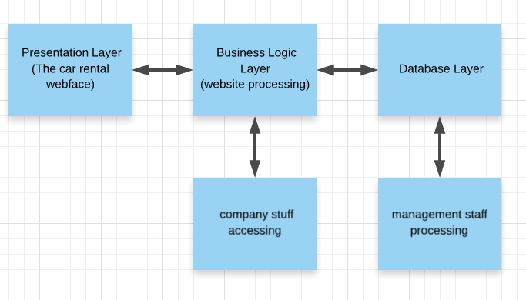

Physical diagrams:

Following diagram is the web based designed application on physical perspective includes 3 tiers architecture which allow to add different physical actions which interact with each of these layers and show the process of how it works on reality. And basically, we can add any details we want in this diagram such as data flow, data process location and progress rate.